**Step by Step procedure to run the project**

Steps to install pythonsoftware and Pycharm IDE

**Note:**

* Some packages are not installed please follow the package_install.docx during the package installation time.

**Requirement :**

Windows : 10, 64bit

Step 1: First download Python Version 3.10.0

https://www.python.org/downloads/

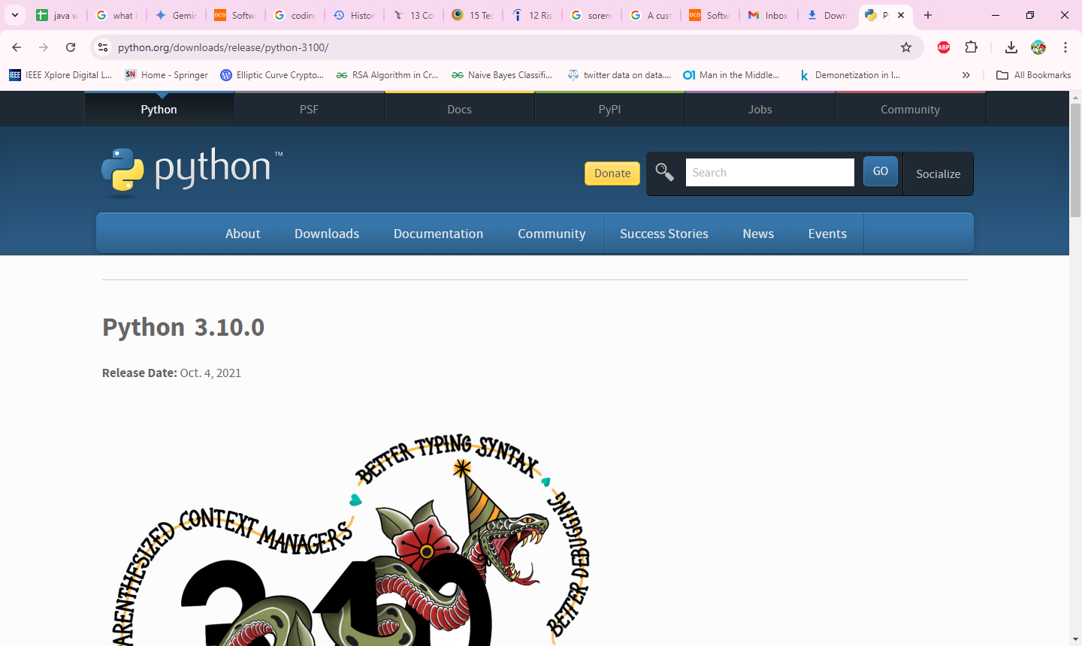

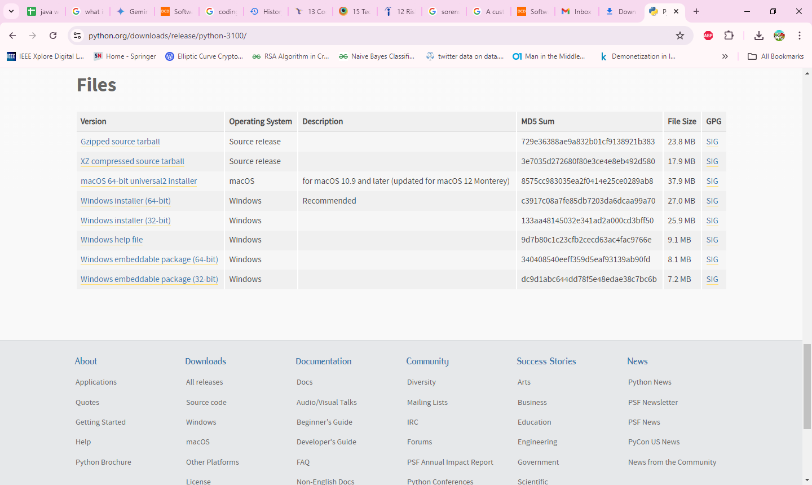

Step 2: After install the python next download the pycharm using below website

<https://www.jetbrains.com/pycharm/download/#section=windows>

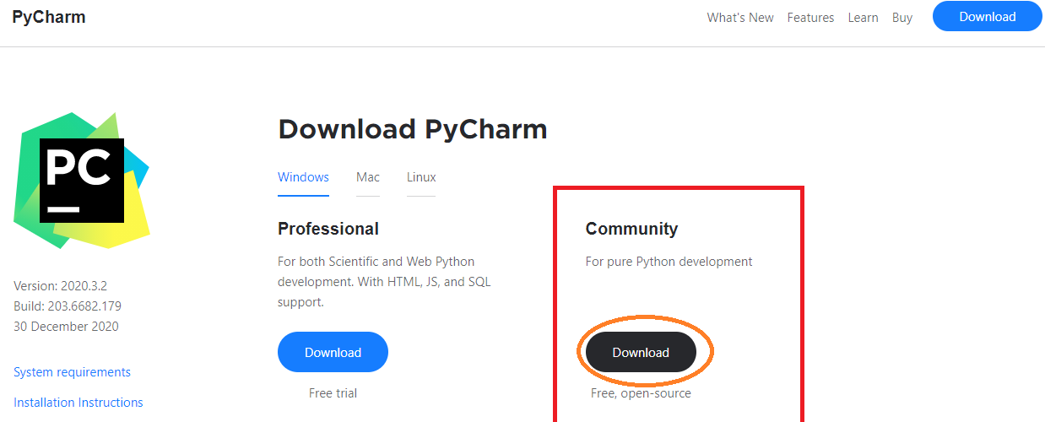

Step 1: After install the pycharm extract the rar file. Right click the Code rar file and select “ Extract Here”.

**Step 3:**Open pycharm IDE and click “File” menu and click “Open” option.

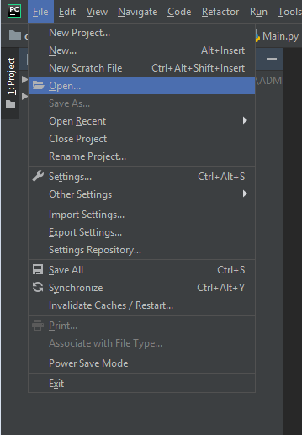

**Step 4:**After select the “Open ” the Open dialogue box will be opened. In that select the project where you have stored and click “OK” button.

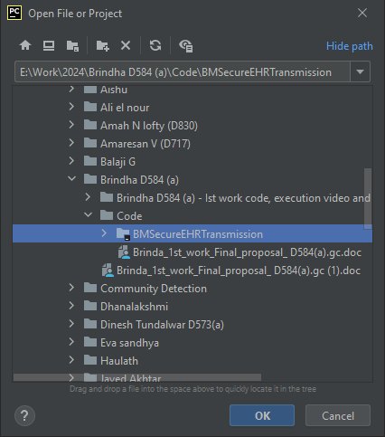

**Step 5:** After open the project the window will be like this.

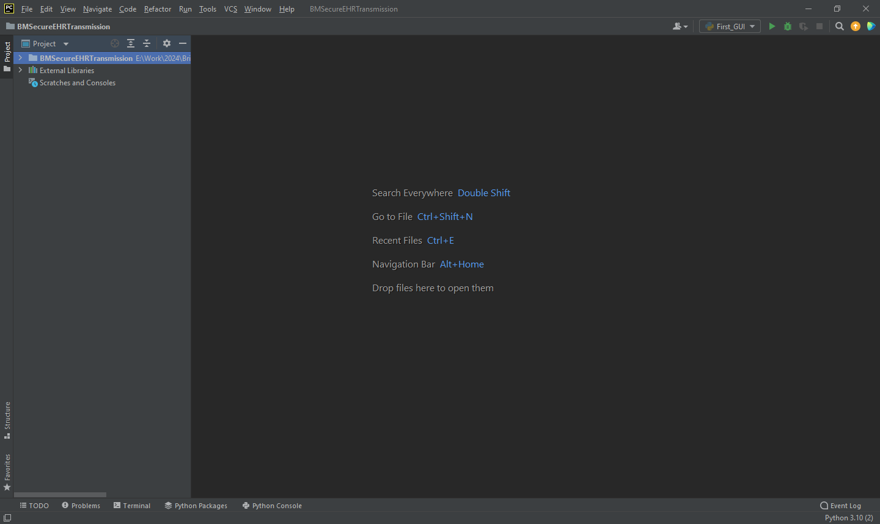

**Procedure to Run the Project**

**Step 1:** Expand the project the Open BMSecureEHRTransmission/ EHR/ Code/ package. Inside that **First_GUI.py** file is available. Right click the code and select **Run ‘First_GUI.py’**

